TEAM ID:PNT2022TMID30495

TITLE:classification of Arrythmia by using deep leaning 2-D ECG spectral image representation

DATE: 19 November 2022

DATA COLLECTION

Collect images of different food items organized into sub directories based on their respective names as shown in the project structure.

Create folders of types of food items that need to be recognized.

In this project, we have collected images of 5 types of food items apples, 'banana', 'orange', 'pineapple' and 'watermelon', they are saved in the respective sub directories with their respective names.

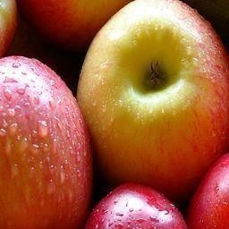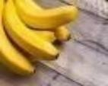

For more accurate results we can collect images of high resolution and feed the model with more images.

DataSet:/content/drive/MyDrive/IBM